Course Title: Micronutrients

Grade Level: High School 9-12

Description:
In this course, you will learn about what micronutrients are, the role they play in the body, and how to keep track of them. It is important for you to understand what micronutrients are because they regulate metabolism and are chemical catalysts to produce hormones, enzymes, and vitamins used in the body.

Course Image:
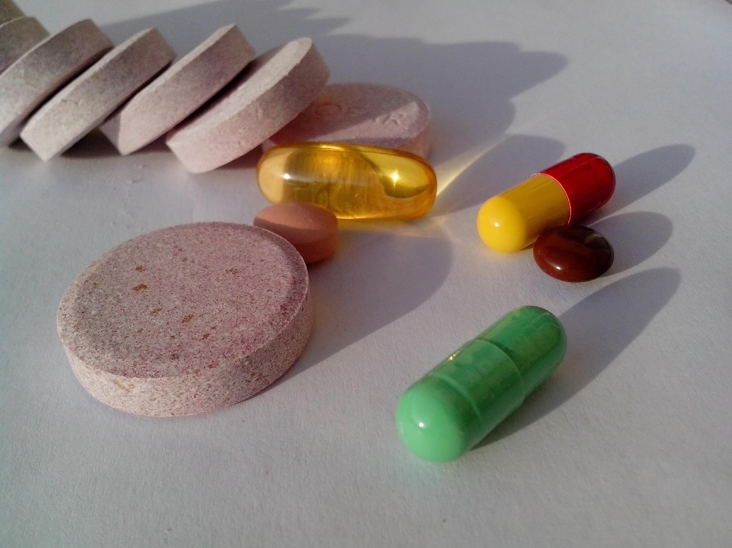
Video URL:
https://www.youtube.com/watch?v=TBNCqRCsSvY

